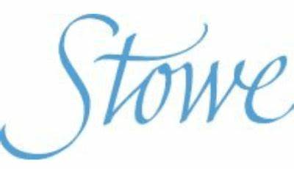

Northants Schools Chess Association
Stowe School Championships
Sunday, May 12th^{th} 2024

An Under 11 and Under 18 Chess Tournament.
at
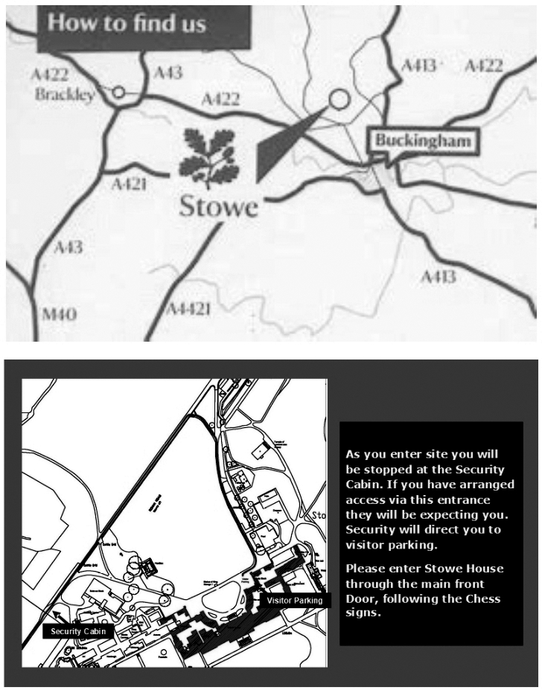
Stowe School
Buckingham
MK18 5EH

Players of all abilities will be welcome.

Closing date for entries: Thursday, May 9th.

No late entries will be accepted.

The tournament will be managed by Stowe School in association with the
Northamptonshire Schools’ Chess Association.

Directions

There is ample, free visitor parking, and it is located close to the House.

Please use postcode: MK18 5EH

General Information

Stowe School reserves the right to refuse entry to the competition without explanation. Any entry refused will be notified accordingly.

Players arriving more than 10 minutes late for any round will be defaulted. For round 1, new pairings will be made after ten minutes for all players whose opponents have not arrived.

In all matters, the decision of the Tournament Committee is final

Parents/Guardians or Teachers for school groups are responsible for their children at all times, and in all places, except in the playing rooms during the tournament.

The organisers of the tournament and their helpers are volunteers. They are not able to act ‘in loco parentis’ and they are not able to take responsibility for your child’s actions, or of the actions of anyone that may affect you or your child except in the playing room.

The organisers accept no responsibility for any loss, theft or accident to the competitors or visitors and their belongings at the venue or in the car park and surrounding areas.

Playing Schedule

Six rounds of chess will be played in a Swiss Draw.
All players will compete in every round.
The draw for each round will ensure that players play someone on the same or a similar score.
Each player will be allowed 20 minutes for all moves.
Chess clocks will be used in some sections. Instruction will be given where necessary.

Timings

Registration : 09:00 – 09:45
Round 1 : 10:00 Round 2 : 11:10
Round 3 : 12:20
Lunch: : 12:45-13:30
Round 4 : 13:30
Round 5 : 14:40 Round 6 : 15:50
Presentations : 16:45

Trophies

Trophies, or medals will be awarded to the winner and Runner up in each relevant age group. In the event of a tie, the sum of the cumulative personal scores will be used to determine the winner and the runner-up. Further details will be displayed in the playing rooms.

Refreshments

Availability will be confirmed prior to the congress.

Wifi

Access to the school’s WiFi will be available, but please note that charging points are limited.

Data Protection

All information supplied on this application form will be held securely on behalf of Stowe School by the Northamptonshire Schools’ Chess Association. Under no circumstances will the data be shared. It will be used by Stowe School and/or the NSCA for chess purposes only. Data will be deleted at the request of the player, his/her parents or guardians, Stowe School or when the player reaches 18 years.

Registration

Postal entries (by normal 1st or 2nd class post please) to: Mr. Nigel Mapletoft,
20 Augusta Avenue, Collingtree Park, Northampton, NN4 0XP
Email: Nigel.Mapletoft@sky.com

Entries are requested as early as possible.
Please note that no entries will be accepted after Thursday, May 9th.

Teachers may send in multiple entries in list form.

Fees

Entry fee: £15 for individual players
Plus
£5 each for additional siblings.
Please make cheques payable to ‘NSCA’
or send the fees online (together with a suitable reference) to:
Name: Northamptonshire Schools’ Chess
Association,
Sort code: 08-92-99
A/c Number: 65630473
Entry Form

BLOCK CAPITALS PLEASE

Name _______________________________

Date of birth: ______________ Age (01/09/23) ___

Address: _______________________________

_______________________________

Post Code __________ Tel No: ______________

Email Address: _______________________________
(Confirmation will be emailed to all entrants if a legible email address is provided.)

Club / School: _______________________________

ECF Grade (if known): _________________________

The qualifying date for both age groups is
1st September 2023.

Under 9: Under 11: Under 14: Under 18:

Signature: ___________________________________

