Northamptonshire Schools’ Chess Association.
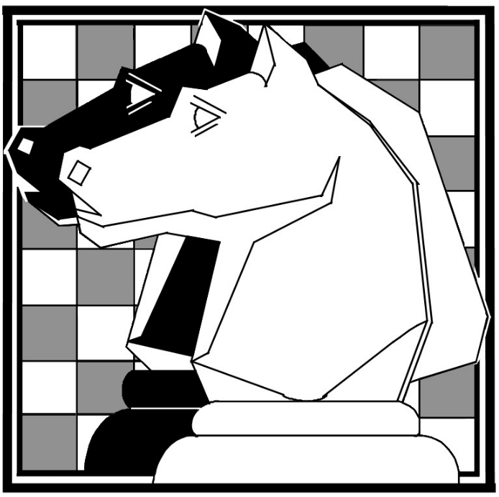

N.S.C.A. County Championships
Sunday, February 5th 2023

An Under 9, Under 11, Under14
and Under 18 chess tournament
at
The Obelisk Centre
400 Obelisk Rise
Northampton NN2 8UE

Players of all abilities will be welcome.

Closing date for entries: Thursday, February 2nd.

No late entries will be accepted.

DIRECTIONS

The Obelisk Centre is located on the northern outskirts of Northampton, a short distance off of the A508/A5076 traffic-lighted junction in Kingsthorpe. From this junction travel east along the A5076 for ½ a mile and then turn left (north) into Reynard Way.

Then take the second right into Obelisk Rise. Travel along Obelisk Rise for ¼ mile until a right turn immediately before a small red Royal Mail postal box. (You will also by now have most probably noticed the Obelisk reaching out of the trees, after which the Centre is named)

northantsjuniorchess.org

General Information

The NSCA reserves the right to refuse entry to the competition without explanation. Any entry refused will be notified accordingly.

Players arriving more than 10 minutes late for any round will be defaulted. For round 1, new pairings will be made after ten minutes for all players whose opponents have not arrived.

In all matters, the decision of the Tournament Committee is final

Important

Parents/Guardians or Teachers for school groups are responsible for their children at all times, and in all places, except in the playing rooms during the tournament.

The organisers of the tournament and their helpers are volunteers. They are not able to act ‘in loco parentis’ and they are not able to take responsibility for your child’s actions, or of the actions of anyone that may affect you or your child except in the playing room.

The organisers accept no responsibility for any loss, theft or accident to the competitors or visitors and their belongings at the venue or in the car park and surrounding areas.

Playing Schedule

Six rounds of chess will be played in a Swiss Draw.
All players will compete in every round.
The draw for each round will ensure that players play someone on the same or a similar score.
Each player will be allowed 20 minutes for all moves.
Chess clocks will be used in some sections. Instruction will be given where necessary.

Timings

Registration : 08:45 – 09:30
Round 1 : 09:40
Round 2 : 10:45
Round 3 : 11:50
Lunch: : 12:30-12:50
Round 4 : 12:55
Round 5 : 14:00
Round 6 : 15:05
Presentations : 16:10
Departure : 16:30 approx.

Trophies

Trophies, shields or medals will be awarded to the first and second-placed player in each age group. In the event of a tie, the sum of the cumulative personal scores will be used to determine the winner and the runner-up. Further details will be displayed in the playing rooms.

Refreshments

Breakfast butties, light snacks, and hot and cold drinks will be available on the day, at reasonable prices.

Wifi
Access to the Centre’s’s WiFi will be available, but please note that charging points are limited.
Data Protection

All information supplied on this application form will be held securely by the Northamptonshire Schools’ Chess Association. Under no circumstances will the data be shared. It will be used by the NSCA for chess purposes only.
Data will be deleted at the request of the player, his/her parents or guardians, or when the player reaches 18 years.

Registration

Postal entries (by normal 1st or 2nd class post please) to: Mr. Nigel Mapletoft,
20 Augusta Avenue, Collingtree Park, Northampton, NN4 0XP
Email: Nigel.Mapletoft@sky.com

Entries are requested as early as possible.
Please note that no entries will be accepted after Thursday, February 2nd.

Teachers my send in multiple entries in list form.

Fees

Entry fee: £10 for individual players
or
£5 each for siblings.
Please make cheques payable to ‘NSCA’
or send the fees online (together with a suitable reference) to:
Name: Northamptonshire Schools’ Chess
Association,
Sortcode: 08-92-99
A/c Number: 65630473

Entry Form

BLOCK CAPITALS PLEASE

Name _______________________________

Date of birth: ______________ Age (01/09/22) ___

Address: _______________________________

_______________________________

Post Code __________ Tel No: ______________

Email Address: _______________________________
(Confirmation will be emailed to all entrants if a legible email address is provided.)

Club / School: _______________________________

ECF Grade (if known): _________________________

The qualifying date for both age groups is
1st September 2022.

Under 9: Under 11: Under 14: Under 18:

Signature: ____________________________

